2.3 Assignment Name __________________________

To Be or Not To Be a Function?
Defining and Recognizing Functions

1. A history teacher asks six of her students the number of hours that they studied for a recent test. The following diagram maps the grades that they received on the test to the number of hours that they studied.

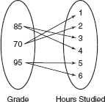

a. Is the relation a function? If the relation is not a function, state why not.

b. Write the set of ordered pairs to represent the mapping.

c. What does the first value in each ordered pair in part (b) represent? What does the second value in each ordered pair represent?

d. Complete the following scatter plot. Does the graph agree with your conclusion from part (a)? Explain your reasoning.

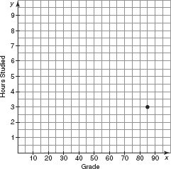

2. Suppose a teacher asks six students the number of hours they studied, and the set of ordered pairs was {(100, 6), (90, 5), (80, 3), (70, 1), (90, 4), (80, 2)}. Create a mapping from this set of ordered pairs.

a. Is the relation a function? If the relation is not a function, state why not.

b. List all the inputs of the relation.

c. List all the outputs of the relation.

d. Instead of mapping grades to hours studied, the teacher decides to create a new diagram for her first set of students. This diagram maps hours studied to grades. Show the mapping that would result.

e. Write the set of ordered pairs to represent the mapping in part (d).

f. Is the relation in part (d) a function? If the relation is not a function, state why not.

g. Complete the scatter plot shown. Does the graph agree with your conclusion from part (f)? Explain your reasoning.

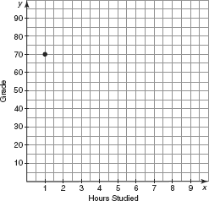

3. At the end of the year, a principal decides to create the following mapping.

Input: The 82 total students in the history class

Output: The final grades they received for the class

Does this mapping fit the definition of a function? Explain your reasoning.

4. Suppose a teacher writes the following equation that relates the amount of time the students studied to their final grades.

y = 10x + 40

Let x represent the number of hours studied and y represent the grade.

a. Determine whether the equation is a function. Explain your reasoning.

b. List three ordered pairs that are solutions to the equation.

c. What conclusion can the students make about the relationship between hours studied and grade?

