2.7 Skills Name ____________________________

Sketch a graph of each given function.

1. absolute value function 2. Square or quadratic function

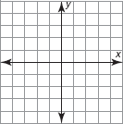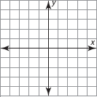

3. cube or cubic function

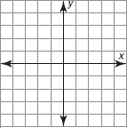

Complete the table for each given function and use the values to graph the function. (on your graph paper)

4.

x
0
1
3
6

5. 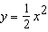

x
0
1
3
4

6.

x
0
1
1.2
1.7
2

7. 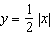

x
0
2
4
8

8.

x
0
1
2
3

9. 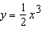

x
0
1
2
2.5

10.

x
0
1
2
4

11. 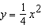

x
0
2
4
6

