3.1 Assignment Name _____________________________

1. The graph shows the number of cups of flour needed for making rolls.

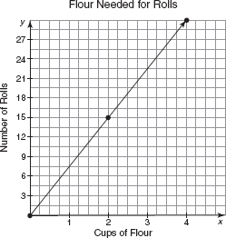
a. Determine the rate of change.

b. Determine the number of cups of flour needed to make 75 rolls for a dinner party. Show your work.

2. Kodiak is riding her skateboard down a hill, as shown on the graph.

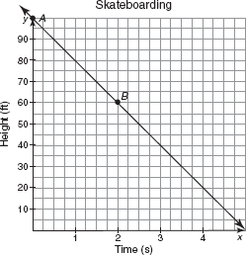

a. Explain what point A represents.

b. Explain what point B represents.

c. How many seconds will it take Kodiak to reach the bottom of the hill?

d. How many feet down the hill is Kodiak skateboarding per second?
3. The graph shows the amount that Roger still owes on a television he bought. Determine the rate of change and the unit rate of change for the graph.

