Chapter 3 Review

1. The graph shows the number of cups of flour needed for making rolls.

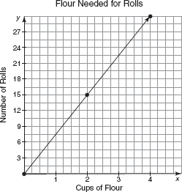

a. Determine the rate of change.

b. Determine the number of cups of flour needed to make 75 rolls for a dinner party. Show your work.

2. Kodiak is riding her skateboard down a hill, as shown on the graph.

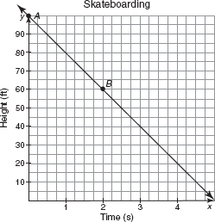
a. Explain what point A represents.

b. Explain what point B represents.

c. How many seconds will it take Kodiak to reach the bottom of the hill?

d. How many feet down the hill is Kodiak skateboarding per second?
3. The graph shows the amount that Roger still owes on a television he bought. Determine the rate of change.

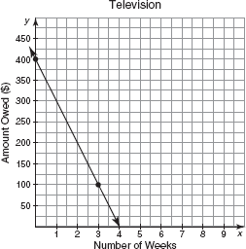

4. Leroy has already accumulated 24 hours of paid time off from his job. The table shows the total number of hours of paid time off that Leroy can continue to accumulate after working various numbers of weeks.

Number of  Weeks Worked | Number of Hours of  Paid Time Off
0 | 24
2 | 31.5
6 | 46.5
16 | 84
36 | 159

a. Calculate the rate of change.

b. Explain why the graph is linear.

c. Name the independent and dependent variables in this problem situation. (x and y)

d. Determine the domain of this problem situation. (List them out)

e. Determine the range of this problem situation. (List them out)

5. The table shows the points the Bulldogs scored after various minutes of game play have elapsed. Calculate the rate of change using an informal method.

Number of Minutes  of Game Played | Number of Points Scored
5 | 10
8 | 16
14 | 28
22 | 44

6. Solve for Y. Examine each and determine the y-intercept and slope.

a. 9x + 2y = 36

b. y + 5 = 7(x + 3)

Slope-Intercept Form
Determining the Rate of Change and y-Intercept

7. Calculate the y-intercept of each line when given the slope and one point that lies on the line. Show your work. (Remember to use y=mx+b)

a. m = 2; (5, 6)

b. m = 9.2; (17, 10)

8. Write the equation of a line using the given two points that lie on the line. Find slope and then the y-int, use y=mx+b.

a. (2, 3), (8, 8)

b. (79, 52), (87, 550)

Problem Set

Write a rate for each situation. (slope) Remember to reduce and label!

9. Use the graph to write a rate that compares the track length to the change in time at point A.

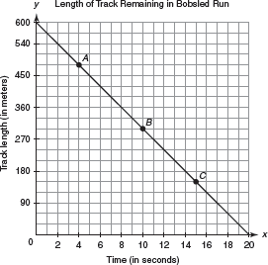

Problem Set
Find the slope and determine if the points given are linear. Your answer should be slope AND Linear or Not Linear.

10. 11.
Number of Balloons | Total Cost of Balloons (in Dollars)
2 | 6
4 | 12
6 | 18
8 | 24
Number of Lawns | Total Earned (in Dollars)
3 | 25.50
5 | 42.50
7 | 59.50
9 | 76.50

Determine the slope and y-intercept of the line represented by each equation. (the m and the b)

12.

13.

14.

Graph the equation. Determine the slope and y-intercept.

15. 16. 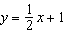

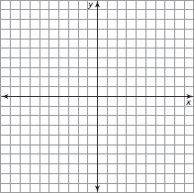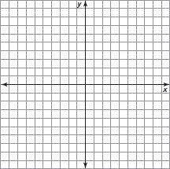

17.

Determine the y-intercept and slope.

18.

19.

Determine the y-intercept of each line given the slope and a point that lies on the line.

20.

21. 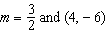

Write the equation of each line given two points that lie on the line. Remember to find the slope and then the y-intercept. Use y=mx+b.

22. (3, 25) and (4, 31)

23. (10, 22) and (15, 24)

Write the equation of each line given the slope and a point that lies on the line. Write the equation in slope-intercept form (y=mx+b). First find the y-intercept and then plug into the slope-intercept form.

24.

25.

