Assignment 16.3 Name ________________________________

Create a scatter plot of the ordered pairs on each grid provided, and find the equation of the line of best fit. Use your equation to answer the question. Be sure to label your graph clearly.

1. Your little sister’s classroom has a pet baby turtle. They let it swim in a tank and record its distance at certain times. Using your line of best fit, predict how far the baby turtle will swim in 30 seconds.

Tracking a Turtle
Time  (in seconds) | Distance  (in meters)
5 | 3
6 | 3.3
10 | 4.1
11 | 4.5
15 | 6.3
20 | 7.9

2. Your class conducts an experiment. You ask shoppers at different stores how much change they have, and you record the total number of shoppers and the total dollar amount of change among them. If you encountered 25 shoppers, how much change, in dollars, would you expect them to have altogether? Use your line of best fit to approximate a solution.

Counting Change
Number of  Shoppers | Total Change  (in dollars)
2 | 1.5
5 | 3
7 | 4.2
10 | 4.5
14 | 7
18 | 11

3. Jeremiah prints his digital pictures. After they start printing, he starts recording the time elapsed and the total number of pictures printed. Using your line of best fit, if he prints 30 pictures, approximately how much time, in seconds, will it take?

Printing Pictures
Time  (in seconds) | Number of  Pictures Printed
7 | 6.5
12 | 9.4
15 | 11.5
17 | 13.2
20 | 15
22 | 17.3

4. A fundraiser uses telemarketers to raise money. Every so often, they stop to determine how many phone calls they’ve made and how much money they’ve collected. Using your line of best fit, if the telemarketers raised $250, approximately how many phone calls did they make?

Fundraising Totals
Number of  Phone Calls | Money Collected  (in dollars)
5 | 60
10 | 82.30
12 | 92
13 | 98.70
15 | 100.30
20 | 146

Write an equation for each line of best fit.

5. 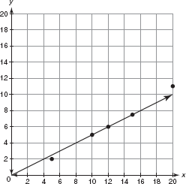

6. 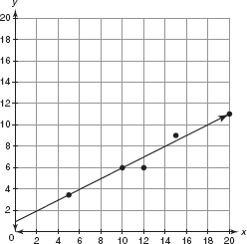

7. 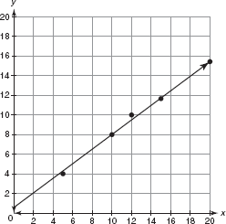

8. 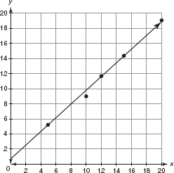

Use each given equation to answer the question.

9. Your sister is moving into a new apartment. To estimate her average heating cost each month in dollars, she uses the equation y = 0.14x, where x is the square footage of her apartment. How much more will it cost her to heat an apartment that is 900 square feet than one that is 700 square feet?

10. Your brother has found a new apartment to rent. It is 800 square feet, and the electricity cost, in dollars per month, will be approximately y = 0.08x, where x is the square footage of the apartment. He doesn’t want to pay more than $60 a month for electricity. Should he rent this apartment?

11. Alice and Monique run a race. Alice’s distance in meters can be approximated using the equation a = 6x and Monique’s distance in meters can be approximated using the equation m = 7x, where x is the time in seconds. If the two girls raced in a 400-meter sprint, who would finish first?

12. Francis and Mario are competing in a 200-meter sprint. Francis’s distance in meters can be approximated by the equation f = 9.09x and Mario’s distance can be approximated by the equation m = 8.89x, where x is the time in seconds. Who would win the 200-meter race between the two boys?

16.3

