2.4 Assignment Name __________________________

Scaling a Cliff
Linear Functions

1. In 1980, George Adrian set the world record for the most apples picked in 8 hours. He picked a total of 15,830 pounds of apples. That’s almost 8 tons of apples! Delilah is practicing so that she can try to beat George’s record. After picking for a while, she finds that she has picked 2 tons of apples. She hopes to pick 2 tons per hour for the next several hours.

a. If Delilah manages to pick at a rate of 2 tons per hour, how many tons of apples will Delilah have picked 1 hour after she starts picking again? Show your work.

b. Which quantities are changing? Which quantities remain the same?

c. Use the information in parts (a) through (c) to complete the table.

Quantity Name | Time | Weight of Apples
Unit of Measure
Expression
 | 1
 | 2
 | 3
 |  | 10
 |  | 12

d. How many more hours will it take Delilah to pick a total of 8 tons of apples?

e. Which variable is the independent variable? Which variable is the dependent variable? Explain your reasoning.

f. Create a graph to represent the values in the table. Remember to label your axes.

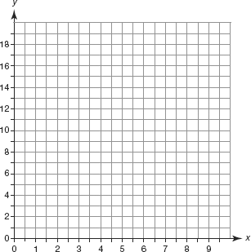

g. Write each row of numbers in your table as an ordered pair. Plot each ordered pair on the grid in part (f). Then, draw a straight line connecting the points and describe the line.

h. Is the relation shown in the graph a linear function? Explain your reasoning.

2.4

